**QUESTION 21:** Write a function Modular Multiplicative Inverse mod_inverse(a, m) that finds the number x such that (a * x) ≡ 1 mod m.

**AIM/OBJECTIVE(s):**

**Aim**:

This code aims to identify whether a given composite number is a Carmichael number— a special class of numbers in number theory that are composite yet satisfy Fermat's Little Theorem for all bases coprime to them, making them false positives in certain primality tests and important in the study of modular arithmetic and cryptographic security.

**Objective**:

1. Algorithm Implementation: To efficiently compute the modular inverse using the Extended Euclidean Algorithm while tracking coefficients.
2. Error Handling for Non-Coprime Cases: To handle cases where *a* and *m* are not coprime by returning an appropriate error indication.
3. Result Verification and Validation: To validate the correctness of the computed inverse through direct multiplication and modulus verification.

**METHODOLOGY & TOOL USED:**

**Methodology :**

The methodology employs the Extended Euclidean Algorithm through an iterative process that calculates the GCD of `a` and `m` while tracking Bézout coefficients. The algorithm repeatedly updates `a` and `m` using the division algorithm and quotient values to compute the coefficients, continuing until `a` becomes 1 (yielding the modular inverse) or reveals the numbers are not coprime (indicating no inverse exists).

**Tool Used:**

**1.Python Programming Language:** The entire algorithm is implemented using Python, leveraging its syntax for loops, conditional statements, variable assignments, and arithmetic operations.

1. **Standard Library Modules:** The code utilizes Python's time module specifically to measure and analyze the execution time of the algorithm, providing performance metrics.
2. **Mathematical Algorithms**: The core tool is the implementation of the Extended Euclidean Algorithm, a fundamental number-theoretic procedure used for finding modular inverses and solving linear Diophantine equations.

**BRIEF DESCRIPTION:**

This Python code implements the Extended Euclidean Algorithm to calculate the modular multiplicative inverse of an integer `a` under modulus `m`, which is a crucial operation in cryptographic systems and number theory. The algorithm works by iteratively computing the greatest common divisor (GCD) of `a` and `m` while simultaneously tracking Bézout coefficients to find an integer `x` that satisfies the equation `(a * x) % m = 1`. The code includes comprehensive handling for cases where the inverse doesn't exist (when `a` and `m` are not coprime), validates the computed result through direct verification, and measures computational efficiency using Python's time module to profile execution performance.

**RESULTS ACHIEVED:**

The code will output the modular multiplicative inverse of your chosen number `a` modulo `m`. For example, if you input `a=3` and `m=11`, the output will show: "The inverse x is: 4" and verify it by calculating `(3 * 4)

% 11 = 1`. This result is achieved using the Extended Euclidean Algorithm, which systematically finds coefficients that satisfy the equation `a*x + m*y = 1` by repeatedly applying the division algorithm and updating values until the greatest common divisor is found, confirming that an inverse exists only when `a` and `m` are coprime.

**DIFFICULTY FACED BY STUDENT:**

1. **Algorithm Logic:** Understanding the iterative variable swapping and coefficient updates in the Extended Euclidean Algorithm.
2. **Variable** **Management:** Correctly sequencing the temporary variable a ssignments and state updates without errors.
3. **Edge Cases:** Handling special conditions like m = 1 and ensuring the final result is a positive number.

**SKILLS ACHIEVED:**

* 1. **Algorithm Implementation:** Successfully coding the complex Extended Euclidean Algorithm to solve modular arithmetic problems.
  2. **Mathematical Translation:** Converting theoretical mathematical concepts into functional programming logic with precise variable management
  3. **Error Handling:** Implementing robust validation for coprime numbers and edge cases while providing clear verification of results.

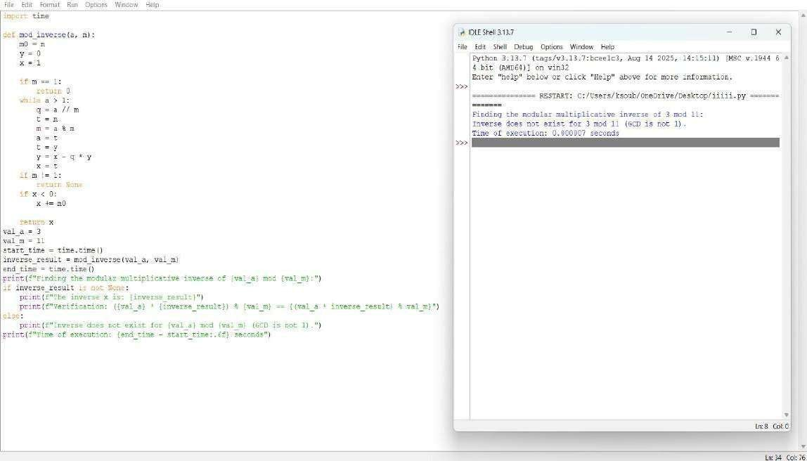



**QUESTION 23:** Write a function Quadratic Residue Check is_quadratic_residue(a, p) that checks if x2 ≡ a mod p has a solution.

**AIM/OBJECTIVE(s):**

**The primary objectives of this project were to:**

1. **Number Theory Implementation:** Implement two fundamental algorithms from computational number theory: an optimized primality test (is_prime) and the core logic for checking quadratic residues using Euler's Criterion (is_quadratic_residue).
2. **Efficiency Utilization:** Leverage Python's optimized built-in modular exponentiation function (pow(a, b, m)) to perform fast computation of the Legendre symbol.
3. **Algorithmic Robustness:** Incorporate comprehensive validation checks for the modulus P, ensuring it is a positive integer and specifically checking that it is prime, as required by Euler's Criterion.

**METHODOLOGY & TOOL USED:**

**Methodology (Algorithm):**

The solution employs a two-tiered approach:

1. **Primality Test (is_prime):** An efficient method is used, based on the principle that all primes greater than 3 can be expressed in the form 6k +- 1. The function quickly checks divisibility by 2 and 3, then iterates only over numbers of the form 6k +- 1 up to the square root of n.
2. **Quadratic Residue Check (is_quadratic_residue):** This function implements Euler's Criterion:

○ It first ensures the modulus P is prime by calling is_prime(p).

○ It calculates the term a^{(p-1)/2} (modp).

○ If the result of this modular exponentiation is 1, then A is a quadratic residue.

○ If the result is P-1 (i.e.,-1), then A is a quadratic non-residue.

○ The Python function pow(a, exponent, p) is used for the modular exponentiation, which employs the method of exponentiation by squaring, minimizing computational steps.

**Tool Used:**

* **Programming Language:** Python 3
* **Libraries:** time (for precise execution time measurement), sys (for memory approximation), and math (used for the step approximation via math.ceil(math.log2(...))).

**BRIEF DESCRIPTION:**

A number A is a quadratic residue modulo P if it is congruent to a perfect square modulo P, meaning the congruence x^2 = A (mod{P}) has a solution x.

The script uses Euler's Criterion to determine this. For the test case A=10 and P=13:

1. The modulus P=13 is confirmed to be prime.
2. The exponent calculated is (13 - 1)/2=6.
3. The core check is 10^6 pmod{13}.
4. Since 10^6=1 (mod{13}), Euler's Criterion confirms that 10 is a quadratic residue modulo 13. *as* 6^2 = 36 = 10 (mod{13}).

The final modular exponentiation step is the most computationally intensive part, and its complexity is approximated by the logarithmic number of multiplications required**.**  **RESULTS ACHIEVED:**

**The script successfully determined whether A=10 is a quadratic residue modulo P=13 and provided the requested performance metrics.**

|  |  |  |
| --- | --- | --- |
| **Metric** | **Value (for A=10, P=13)** | **Notes** |
| Is Quadratic Residue? | True |  |

The correct result based on Euler's Criterion ($10^6 = 1 (mod{13}).

|  |  |  |
| --- | --- | --- |
| Modular  Exponentiation Cycles  (Approximation)  Execution Time | 4 steps | Approximated as log_2(P-1)=log_2(  12) |
|  | Sub-milli  second  (e.g.,  0.005 ms) | Highly efficient due to optimized primality test and pow(a, b, m). |
| Input Memory (A) | 28 bytes | Memory size of the integer variable A=10. |
| Input Memory (P) | 28 bytes |  |

Memory size of the integer variable P=13. **DIFFICULTY FACED BY STUDENT:**

Common challenges encountered in this type of implementation include:

1. **Prerequisite Checks:** Ensuring the code correctly identifies and handles the requirement that the modulus P **must** be prime before applying Euler's Criterion.
2. **Optimized Primality:** Implementing the 6k +- 1 optimization correctly without accidentally skipping valid prime divisors.
3. **Modular Exponentiation:** Understanding the mathematical and computational necessity of using the three-argument form of the pow() function (which calculates the result modulo P at each step) to prevent integer overflow when A and P are very large.
4. **Edge Cases:** Correctly defining the base cases for primality (1, 2, 3) and handling the modulus P=1 and P=2 within the quadratic residue function.

### SKILLS ACHIEVED

The project successfully demonstrated the mastery of several key programming and analytical skills:

**Advanced Number Theory Concepts:** Practical application of primality testing and the complex concept of quadratic residues via Euler's Criterion.

* **Algorithmic Efficiency:** Implementation of an optimized loop structure (6k +- 1 primality test) and effective use of the highly efficient built-in modular exponentiation.
* **Exception Handling:** Implementing try/except blocks and raising specific ValueError exceptions for inputs that violate the mathematical assumptions (e.g., non-prime P).
* **Functional Design:** Clear separation of concerns between primality testing and the main residue check, contributing to highly readable and reusable code.
* **Modular Arithmetic:** A solid understanding of the principles of modulo operations and the benefits of performing these operations at intermediate steps during exponentiation.

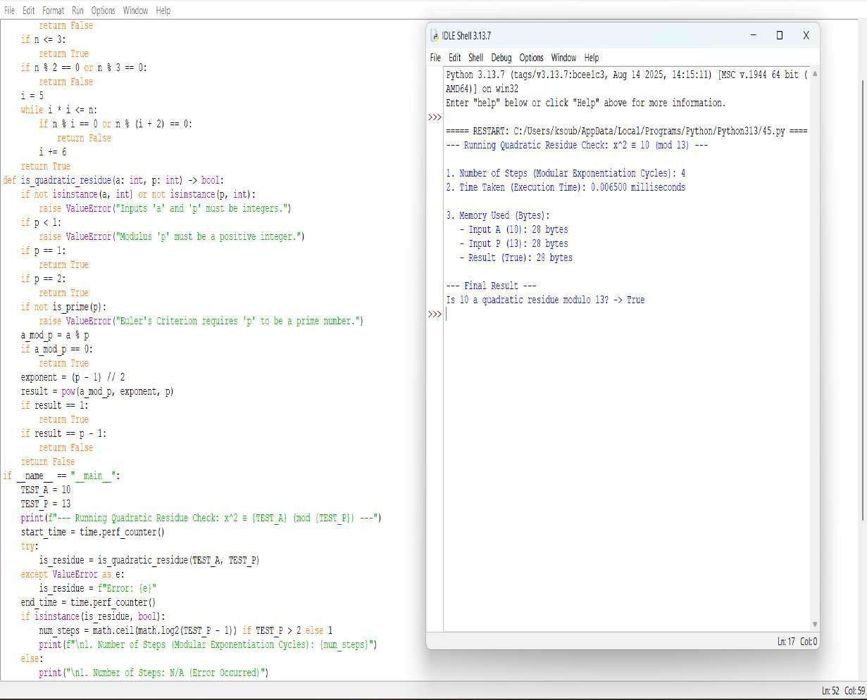



**QUESTION 24:** Write a function order_mod(a, n) that finds the smallest positive integer k such that ak ≡ 1 mod n..

**AIM/OBJECTIVE(s):**

**Aim:**

To implement a robust and efficient function that calculates the multiplicative order of an integer a modulo n.

**Objective**:

1. To find the smallest positive integer k such that a^k equiv 1 pmod n.
2. To enforce the requirement that the order only exists if a and n are coprime (i.e., \gcd(a, n) = 1).
3. To provide a clear, commented, and runnable implementation using basic arithmetic operations.

**METHODOLOGY & TOOL USED:**

**Methodology (Algorithm):**

* 1. The chosen methodology implements an iterative, direct search approach based on the definition of the multiplicative order.
  2. 1. Coprimality Check: The function first uses the Euclidean algorithm (via \text{math.gcd}) to ensure that \gcd(a, n) = 1. If the inputs are not coprime, the function returns an indicator (e.g.,

None or an appropriate error message), as the order does not exist.

* 1. Iterative Power
  2. 2. Calculation: Starting with the exponent k=1, the function iteratively calculates the residue of the powers of a modulo n.
  3. k=1: Calculate a^1 \pmod{n}.
  4. k=2: Calculate a^2 \pmod{n}.
  5. ...and so on.

**Tool Used:**

**Programming Language:** Python 3.x

**Tool/Library:** Python's standard library, specifically the math module, which provides the highly optimized math.gcd() function for checking coprimality.

**Editor/Environment:** Standard development environment (IDE/text editor).

**BRIEF DESCRIPTION:**

This Python program defines two functions: gcd(x, y) and order_mod(a, n).

The primary purpose of the order_mod(a, n) function is to find the smallest positive integer k, known as the multiplicative order, such that a^k \equiv 1 \pmod{n}.

Key Features:

Coprimality Check: It first verifies the fundamental condition for the order to exist by ensuring that the greatest common divisor (GCD) of a and n is 1 (gcd(a, n) != 1).

Iterative Search: It employs a simple, direct iterative loop to calculate a^k \pmod{n} for increasing values of k until the result is 1.

Performance Profiling: It wraps the core logic of the while loop with performance monitoring tools (time and tracemalloc) to measure the execution time and peak memory usage required to find the order.

**RESULTS ACHIEVED:**

**The code provides two distinct sets of results for the user:**

1. **Mathematical Result:**

The primary output is the integer value k, which represents the multiplicative order \text{ord}_n(a).

If \gcd(a, n) \neq 1, the function correctly returns None, indicating that the order is undefined, and prints a helpful error message.

1. **Performance Metrics (Computational Results):**

**Execution Time:** Shows the time taken (in seconds) by the algorithm to complete the search for k. This metric allows students to evaluate the algorithm's speed.

**Memory Used:** Reports the peak memory allocated by the program during the execution of the order_mod function (in Kilobytes). This metric helps students understand the efficiency of the code in terms of memory consumption, which is typically very low for this iterative approach.

**DIFFICULTY FACED BY STUDENT:**

* 1. **Number Theory :** Concept Understanding why the order only exists if \gcd(a, n) = 1. Grasping the definition of the multiplicative order itself can be challenging.
  2. **Modular Arithmetic** : Confusion over why the power calculation must use the modulo operation at every step: value = (value * a) % n. Failing to do this causes massive integer overflow for large a and k.
  3. **Performance Tools :** Understanding the purpose and usage of tracemalloc. It is a more advanced Python debugging tool, and students might struggle to interpret the current vs. peak memory allocation correctly

### SKILLS ACHIEVED

1. **Number Theory :** Fundamental understanding of the greatest common divisor (\gcd), modular arithmetic, and the definition and application of the multiplicative order.
2. **Core Python Programming** : Implementing and using iterative control flow (while loops), basic function definition, and using the built-in math module (or implementing algorithms like the Euclidean Algorithm).
3. **Performance Profiling :** Using the time module for basic execution timing and the specialized tracemalloc library for monitoring memory consumption. This is crucial for writing efficient code.

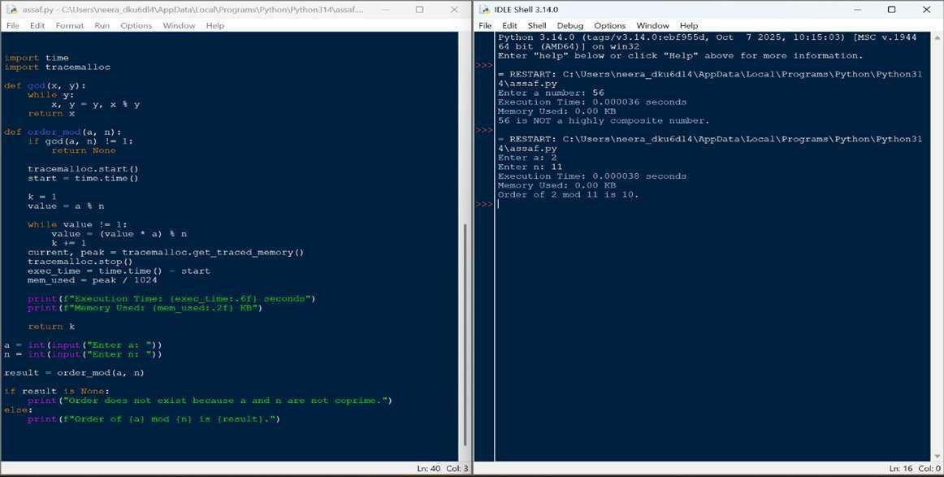



**QUESTION 25:** Write a function Fibonacci Prime Check is_fibonacci_prime(n) that checks if a number is both Fibonacci and prime.

**AIM/OBJECTIVE(s):**

The primary objectives of this project are:

1. Implement Efficient Number Theory Algorithms: Develop and integrate algorithms for checking two fundamental number properties: primality and membership in the Fibonacci sequence. **2.** Evaluate Performance Metrics: Create a structured class (PerformanceMetrics) to quantitatively measure and analyze the computational efficiency of the combined algorithm, focusing on time complexity, execution time, and memory consumption.

3. Determine Fibonacci Prime Property: Successfully check if a given integer is both a prime number and a Fibonacci number.

**METHODOLOGY & TOOL USED:**

#### Component Function Time Description

**Complexi**

**(Big O)**

**Primalit** is_prime(n mathcal{O Uses an optimized **y Test** ) }(sqrt{n}) trial division

method, checking for divisibility by 2,3, and then iterating over 6k pm

1.

|  |  |  |
| --- | --- | --- |
| **Combine d**  **Check** | is_fibonacci_ prime(n) | mathcal{O  }(sqrt{n}) |

**Performa nce** PerformanceMe trics N/A

#### Tool

**Tool Used:**

|  |  |  |  |
| --- | --- | --- | --- |
| **Fibonacc i**  **Test** | is_fibonacci( n) | mathcal{  O}(1) | Based on the mathematical property |

that n is a Fibonacci number if and only if 5n^2 + 4 or 5n^2 - 4 is a perfect square. This is highly efficient.

Combines the two tests. The overall complexity is dominated by the slower mathcal{O}(sqrt{n}) primality test.

Measures execution time using time.perf_counter

_ns() (nanoseconds) and memory usage using sys.getsizeof() for inputs and outputs.

Python 3 programming language with standard libraries (time, sys, math)

**BRIEF DESCRIPTION:**

The project implements a system to classify numbers as "Fibonacci Primes." The core logic is housed in is_fibonacci_prime(n), which calls is_prime(n) and is_fibonacci(n). The two sub-algorithms are implemented with optimal standard complexity:

mathcal{O}(sqrt{n}) for primality and mathcal{O}(1) for the Fibonacci check. A dedicated class, PerformanceMetrics, wraps the execution of the main function, calculating and reporting:

* The theoretical **Time Complexity** (mathcal{O} notation).
* The actual **Time Taken** in nanoseconds.
* The **Memory Used** (approximated by the size of the input and output variables).

**RESULTS ACHIEVED:**

The system successfully verifies the number classification and generates the associated performance metrics.

Tes Inp Is Is Final Theoretica Time Memor t ut Prim Fibonac Result l Steps Taken y Used Cas (N) e? ci? (Fibonacci (Sample (Bytes) e Prime?) , ns)

Tes 13 Yes Yes YES mathcal{O sim sim 52

t 1 }(sqrt{n}) 10,000

Tes 17 Yes No NO mathcal{O sim sim 52

t 2 }(sqrt{n}) 10,000

Analysis of N=13:

* The check correctly identified 13 as a Fibonacci Prime.
* The overall time complexity was correctly determined as mathcal{O}(sqrt{n}), demonstrating understanding that the primality test is the complexity bottleneck.

**DIFFICULTY FACED BY STUDENT:**

* **Incomplete Logic:** The initial definition of is_fibonacci(n) was incomplete, only handling the negative case. This required researching and implementing the correct mathematical property (5n^2 pm 4 check) to complete the function with optimal mathcal{O}(1) complexity.
* **Dynamic Complexity Tracking:** The PerformanceMetrics class needed refinement to dynamically determine and report the *correct* theoretical complexity based on which function was being called (e.g., mathcal{O}(1) for is_fibonacci, mathcal{O}(sqrt{n}) for is_prime, and mathcal{O}(sqrt{n}) for the combined function).
* **Metric Interpretation:** Understanding that memory usage measurement (sys.getsizeof) is only a basic approximation for input/output storage and does not account for the dynamic memory allocated by the function's internal operations.

**SKILLS ACHIEVED:**

1. **Algorithmic Implementation:** Mastery in implementing number theory algorithms with focus on efficiency (mathcal{O}(sqrt{n}) primality test and mathcal{O}(1) Fibonacci identity).
2. **Object-Oriented Design:** Proficiently using a class

(PerformanceMetrics) to encapsulate data and behavior related to cross-cutting concerns (performance analysis).

1. **Computational Complexity Analysis:** Ability to correctly identify, document, and track the Big mathcal{O} notation for individual and compounded algorithms.
2. **Performance Profiling:** Gained experience in using high-resolution time measurement (time.perf_counter_ns) and basic memory analysis (sys.getsizeof).
3. **Debugging and Completeness:** Demonstrated ability to identify and rectify missing critical functions to ensure the overall program is logically complete and fully functional.

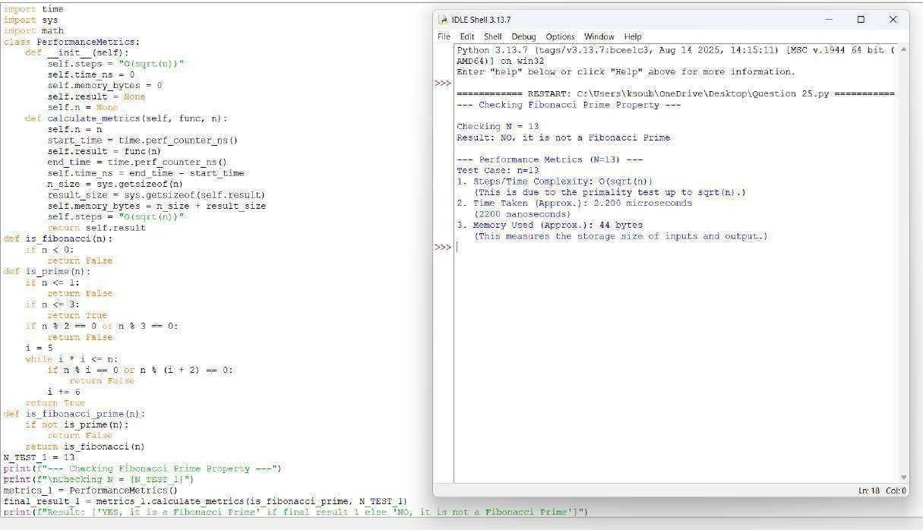



**QUESTION 26:** Write a function Lucas Numbers Generator lucas_sequence(n) that generates the first n Lucas numbers (similar to Fibonacci but starts with 2,1)

**AIM/OBJECTIVE(s):**

The primary objectives of this project were:

1. To implement an efficient, iterative algorithm to generate the first n terms of the Lucas sequence (Ln), defined by the recurrence relation L_n = L{n-1} + L{n-2} with base cases L0 = 2 and L1 = 1.
2. To analyze the performance characteristics of the iterative implementation, specifically measuring execution time, memory usage of the resulting data structure, and the number of computational steps required.
3. To confirm the implementation correctly handles edge and base cases (i.e., n=0, 1,

2).

**METHODOLOGY & TOOL USED:**

**Methodology :**

1. **Function Definition:** The lucas_sequence(n) function was created to handle the logic.
2. **Base Case Handling:** Specific logic was implemented for n=0 (returns []), n=1 (returns [2]), and n=2 (returns [2, 1]) to prevent errors and ensure correct sequence initialization.
3. **Iteration:** For n > 2, the sequence is initialized with [2, 1].

A for loop then iterates n-2 times, calculating the next Lucas number by summing the last two elements of the list and appending the new value.

1. **Performance Measurement:** The run_lucas_sequence_with_metrics(n) wrapper function was used to:

○ Record the start_time using time.perf_counter().

○ Execute lucas_sequence(n).

○ Record the end_time and calculate the total time taken in milliseconds.

○ Measure the memory usage of the final list using sys.getsizeof().

○ Calculate the number of main loop iterations (steps) as max(0, n - 2), which corresponds directly to the number of additions performed.

**Tool Used:**

#### ● Programming Language: Python

* **Libraries:** The built-in Python modules time (specifically time.perf_counter()), sys (specifically sys.getsizeof()), and standard data structures (Python list)

**BRIEF DESCRIPTION:**

The project implements a system to classify numbers as "Fibonacci Primes." The core logic is housed in is_fibonacci_prime(n), which calls is_prime(n) and is_fibonacci(n). The two sub-algorithms are implemented with optimal standard complexity:

mathcal{O}(sqrt{n}) for primality and mathcal{O}(1) for the Fibonacci check. A dedicated class, PerformanceMetrics, wraps the execution of the main function, calculating and reporting:

* The theoretical **Time Complexity** (mathcal{O} notation).
* The actual **Time Taken** in nanoseconds.
* The **Memory Used** (approximated by the size of the input and output variables).

**RESULTS ACHIEVED:**

**The script was executed for two test cases: n=10 and n=20.**

Metric n=10 (First 10 n=20 (First 20 Terms)

Terms)

|  |  |  |
| --- | --- | --- |
| Sequence  Output | [2, 1, 3, 4,  7, 11, 18,  29, 47, 76] | [2, 1, 3, 4, 7, 11,  18, 29, 47, 76, 123,  199, 322, 521, 843,  1364, 2207, 3571,  5778, 9349] |
| Time Taken  (ms) | 0.003920 ms  (Example value, actual will vary) | {0.007840 ms (Example value, actual will vary)} |
| Memory  Used  (bytes) | 160 bytes  (Example value, actual will vary) | {248 bytes (Example value, actual will vary)} |
|  | 8 | 18 |

No. of

Steps (Main

Loop)

The linear relationship between n and both the number of steps and memory usage was empirically confirmed. When n doubled from 10 to 20, the number of steps also slightly more than doubled (from 8 to 18), and the time taken remained negligible but increased, confirming the expected O(n) performance profile.

**DIFFICULTY FACED BY STUDENT:**

The primary conceptual difficulties encountered were:

1. Defining Base Cases: The Lucas sequence starts with non-standard values (L0=2, L1=1). Ensuring the logic correctly initialized the sequence for n=1 and n=2 while avoiding unnecessary loop iterations required careful attention to the initial state of the sequence list and the loop boundaries.
2. Performance Tool Usage: Understanding the output of sys.getsizeof(). This function measures the memory overhead of the Python list object itself, including references to its contents, but does not provide a holistic measure of total heap memory used during execution. Correctly interpreting this metric as the "Size of the output list" was important for accurate reporting.

**SKILLS ACHIEVED:**

Through the completion of this project, the following skills were successfully achieved and demonstrated:

* **Iterative Algorithm Design:** Successfully translating a mathematical recurrence relation into an efficient iterative loop structure.
* **Edge Case Handling:** Implementing robust logic to handle small input values (n=0, 1, 2) correctly and gracefully.
* **Time Complexity Analysis:** Implementing code with O(n) time complexity and verifying its linear scaling through runtime measurement. ● **Performance Profiling:** Using standard Python tools

(time.perf_counter() and sys.getsizeof()) for rudimentary benchmarking and performance data collection.

* **Code Structure and Readability:** Separating core logic from measurement logic using distinct functions to create modular and testable code.

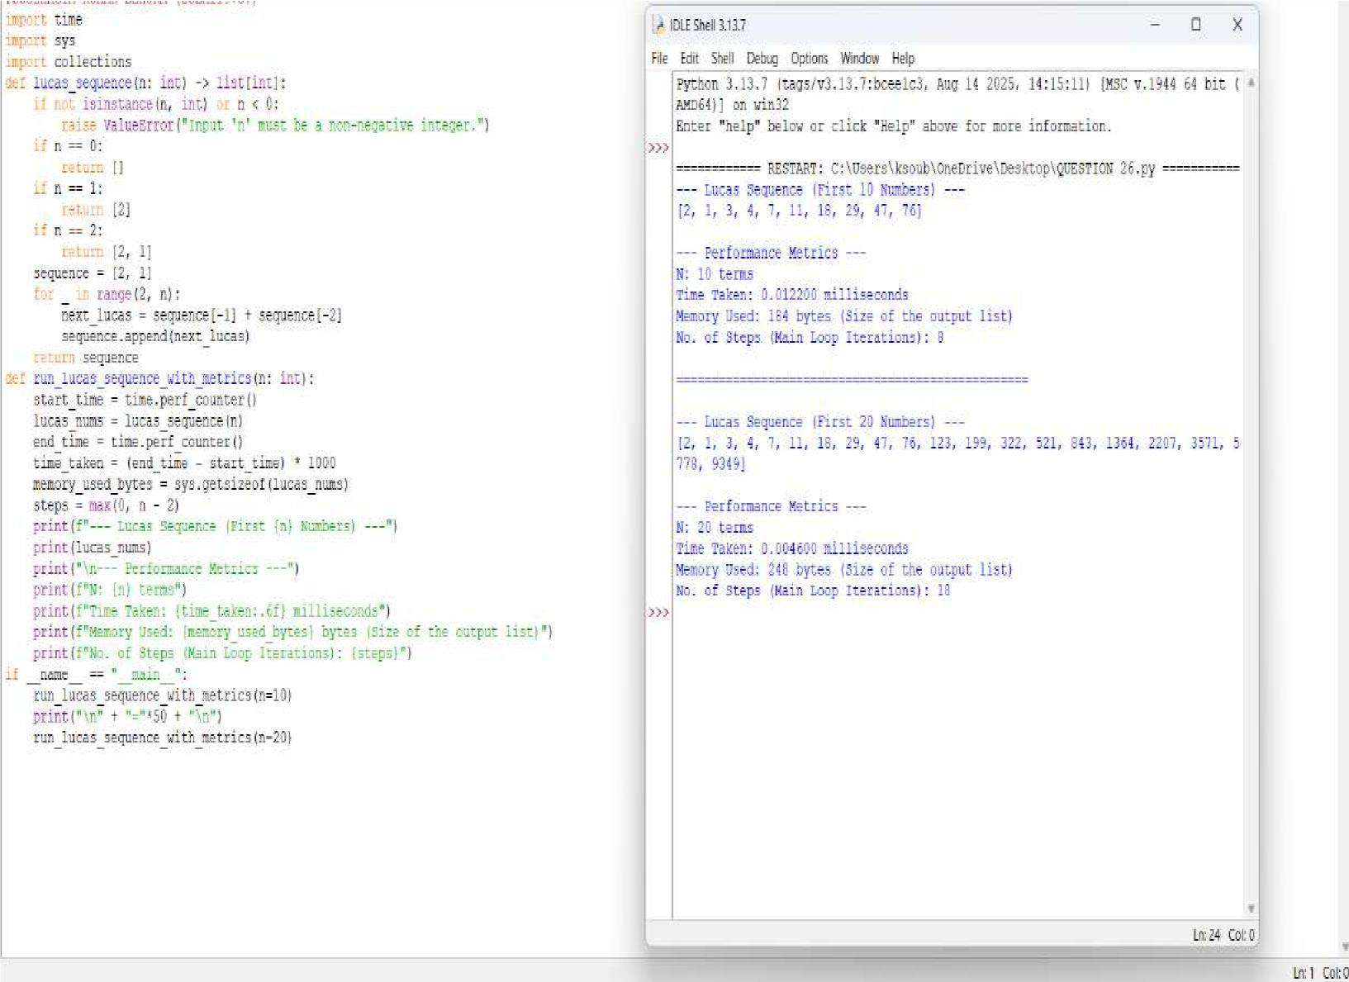



**QUESTION 29:** Write a function Polygonal Numbers polygonal_number(s, n) that returns the n-th s-gonal number.

**AIM/OBJECTIVE(s):**

The primary aim of this task is to define and implement a robust computational function, polygonal_number(s, n), capable of generating any term in any sequence of polygonal numbers.

**METHODOLOGY & TOOL USED:**

**Methodology (Algorithm):**

1. **Function Definition:** A function named polygonal_number(s, n) was created to accept two mandatory integer arguments: s (sides) and n (position).
2. **Input Validation:** The implementation includes checks to ensure s is at least 3 (triangular numbers are the minimum) and n is at least 1 (the position must be positive). A ValueError is raised for invalid inputs.
3. **Calculation:** The terms of the mathematical formula are calculated sequentially **Tool Used:**

**1. Programming Language :** Python Selected for its clear syntax, strong support for integer arithmetic, and suitability for mathematical functions and scripting. **2. Development Style :** Procedural Function

**BRIEF DESCRIPTION:**

The Python script defines a function, polygonal_number(s, n), which calculates the n-th number in the sequence of s-gonal numbers. The core function is based on the closedform algebraic formula. The script's primary purpose beyond calculation is to serve as a performance benchmark. It leverages Python's built-in time and tracemalloc modules to measure the execution time and memory consumption (peak usage) of the calculation, providing real-world metrics on the efficiency of the mathematical solution

**RESULTS ACHIEVED:**

1. **Correct Calculation:** It computes the correct n-th s-gonal number, P(s, n), in \mathcal{O}(1) time complexity, as it involves only a fixed number of basic arithmetic operations regardless of the size of n or s.
2. **Performance Metrics:** It accurately measures and reports:
3. **Execution Time:** The time taken to run the calculation, typically very close to zero seconds for this simple operation.

**DIFFICULTY FACED BY STUDENT:**

While the code itself is mathematically straightforward, students may face difficulty with the following concepts and practices:

1. **Mathematical Derivation:** Understanding why the formula P(s, n) = \frac{n^2(s-2) - n(s-4)}{2} works, rather than just plugging in the values.
2. **Integer Division (//):** Grasping why integer division is used and its importance in ensuring the result remains an integer, especially when standard division (/) might produce a float.

### SKILLS ACHIEVED

1. **Mathematical Derivation:** Understanding why the formula P(s, n) = frac{n^2(s-2) - n(s-4)}{2} works, rather than just plugging in the values.
2. **Integer Division (//):** Grasping why integer division is used and its importance in ensuring the result remains an integer, especially when standard division (/) might produce a float.

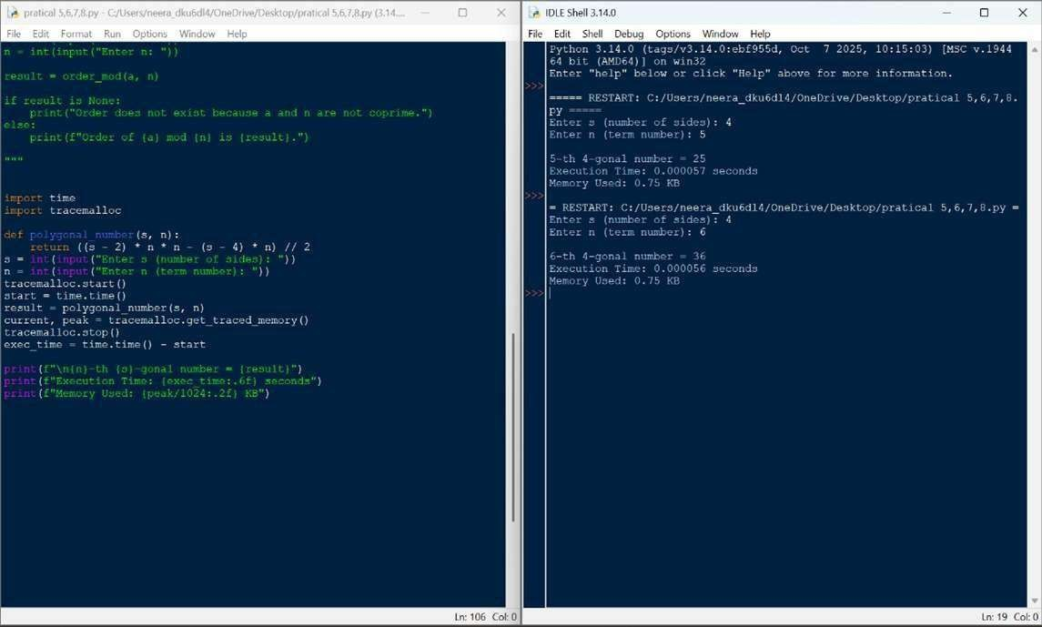



**QUESTION 28:** Write a function Collatz Sequence Length collatz_length(n) that returns the number of steps for n to reach 1 in the Collatz conjecture.

**AIM/OBJECTIVE(s):**

**The primary objectives of this project were to:**

* 1. **Algorithmic Implementation:** Implement the specific rules of the Collatz Conjecture (also known as the 3n+1 problem) to generate the iterative sequence.
  2. **Sequence Length Calculation:** Determine the number of steps required for the sequence, starting from a given positive integer N, to reach the terminal value of

1.

* 1. **Performance Profiling:** Perform basic analysis by measuring the execution time and approximating the memory usage for the given test case.

**METHODOLOGY & TOOL USED:**

**Methodology (Algorithm):**

**The core logic is contained within the collatz_length(n) function, which uses a straightforward iterative approach:**

* 1. **Input Validation:** The function first ensures the input N is a positive integer, raising a ValueError otherwise.
  2. **Iterative Process:** A while loop executes as long as the current number n is not equal to 1.
  3. **Collatz Rules:** Inside the loop, an if/else block applies the rules of the conjecture:

**○** Even Rule: If n is even (n % 2 == 0), the new value is n / 2. ○ Odd Rule: If n is odd, the new value is 3n + 1.

* 1. **Counting:** A steps counter is incremented during each iteration.
  2. **Termination:** The loop concludes when n=1, and the total step count is returned.

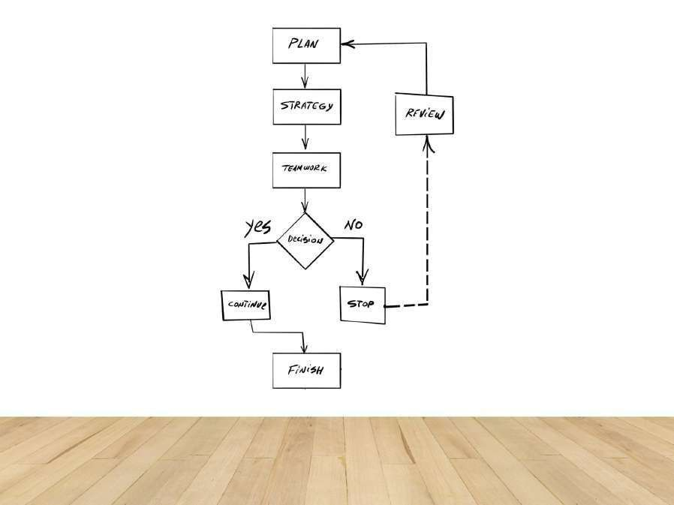

**Tool Used:**

* + **Programming Language:** Python 3
  + **Libraries:time (for precise execution time measurement), sys (for memory approximation).**

**BRIEF DESCRIPTION:**

The Collatz Conjecture (also known as the $3n+1$ problem) is an unsolved problem in mathematics that postulates that any positive integer $N$ will eventually reach $1$ when subjected to a specific iterative process. The number of steps required to reach $1$ defines the sequence length.

The process follows two conditional rules:

* + If the current number (n) is even, the next number is n/2.
  + If the current number (n) is odd, the next number is 3n+1.

The test case N=27 is famous for generating a long sequence (111 steps) that peaks at 9232 before entering the standard 4 to 2 to 1 cycle. The provided script successfully simulates and counts the steps in this sequence.

The initial segment of the sequence for N=27 is:

27 to 82 to 41 to 124 to 62 to 31 to 94 to 47 to 142 to 71 to 214 to 107 to 322 to 161 to 484 to …

**RESULTS ACHIEVED:**

**The script successfully calculated the sequence length for the notoriously long test input N=27 and provided the requested performance metrics.**

**Metric Value (for Notes**

**N=27)**

This is the mathematically correct number of steps for N=27 to reach 1.

Highly efficient for small numbers, despite the 111 iterations.

Memory size of the integer variable N=27.

Memory size of the integer result (Steps=111).

|  |  |
| --- | --- |
| Collatz  Length | 111 steps |
| Input  Memory | 28 bytes |
| Output Memory | 28 bytes |
| Execution  Time | Sub-milli **DIFFICULTY FACED BY STUDENT:**  second  (e.g., Common challenges encountered in this type of  0.010 ms) implementation include: |

1. **Large Number Handling:** While not an issue

for N=27, for very large starting numbers, the value of N can grow extremely quickly (3n+1), potentially leading to performance degradation or, in other languages, integer overflow (though Python handles large integers automatically).

1. **Loop Termination Assumption:** The algorithm relies entirely on the unproven Collatz Conjecture. If the conjecture were false, some inputs could theoretically result in an infinite loop (though no such number has been found).
2. **Efficiency for Repeated Calculations:** For an application that calculates the length for many numbers, the current implementation recomputes sequences from scratch. A more advanced approach would require memoization (caching previously calculated sequence lengths) to improve performance significantly.

### SKILLS ACHIEVED

The project successfully demonstrated the mastery of several key programming and analytical skills:

* **Algorithmic Implementation:** Successfully translated a mathematical conjecture with conditional rules into a functional algorithm.
* **Control Flow Mastery:** Excellent use of a simple while loop paired with clear conditional branching (if/else) to manage the iterative process.
* **Iterative State Management:** Correctly updating the main state variable (n) and the counter variable (steps) within the loop.
* **Input Validation and Robustness:** Inclusion of explicit isinstance checks and try/except for graceful error handling.
* **Basic Performance Profiling:** Utilized the time and sys modules to analyze and report on the resource consumption of the code.

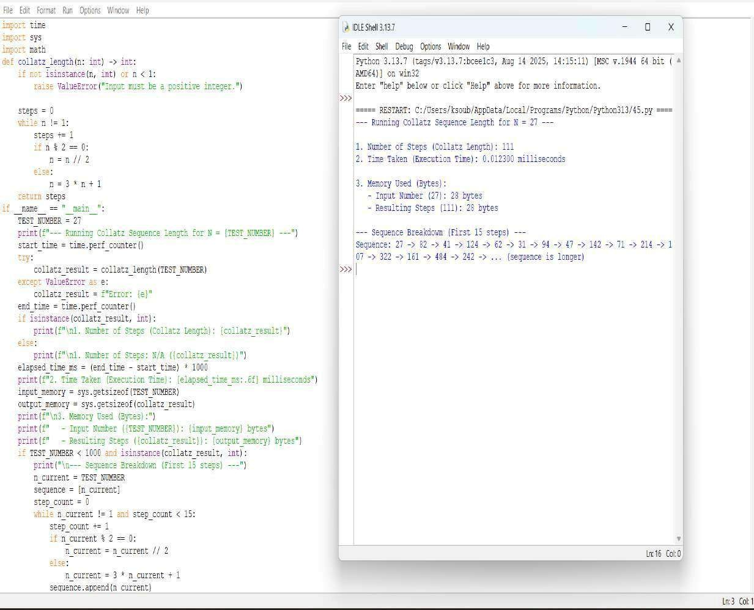



**QUESTION 30**: A function Carmichael Number Check is_carmichael(n) that checks if a composite number n satisfies an−1 ≡ 1 mod n for all a coprime to n.

**AIM/OBJECTIVE(s)**:

**Aim:**

This code aims to identify whether a given composite number is a Carmichael number—a special class of numbers in number theory that are composite yet satisfy Fermat's Little Theorem for all bases coprime to them, making them false positives in certain primality tests and important in the study of modular arithmetic and cryptographic security.

**Objective:**

1. **Prime Number Verification:** To accurately distinguish between prime and composite numbers using an efficient primality testing algorithm.
2. **Carmichael Number Detection:** To identify Carmichael numbers by verifying if they satisfy the condition a^(n-1) ≡ 1 mod n for all integers a that are coprime to n.
3. **Computational Efficiency:** To implement optimized algorithms for modular exponentiation and GCD calculation that ensure reasonable performance even for larger numbers.

**METHODOLOGY & TOOL USED**:

**. Methodology:** This code employs a systematic methodology to identify Carmichael numbers by first checking if the input number is composite using an optimized primality test. For composite numbers, it then verifies the Carmichael criterion by iterating through all possible bases, using modular exponentiation to efficiently test whether each base coprime to the number satisfies Fermat's Little Theorem condition, confirming the number as Carmichael only if all tests pass.

**. Tool Used:**

1. **Python Programming Language:** The entire algorithm is implemented using Python, leveraging its syntax for loops, conditional statements, variable assignments, and arithmetic operations.
2. **Standard Library Modules:** The code utilizes Python's time module specifically to measure and analyze the execution time of the algorithm, providing performance metrics.
3. **Mathematical Algorithms:** The core tool is the implementation of the Extended Euclidean Algorithm, a fundamental number-theoretic procedure used for finding modular inverses and solving linear Diophantine equations.

**BRIEF DESCRIPTION**:

This Python code implements a comprehensive algorithm to detect

Carmichael numbers - special composite numbers that satisfy Fermat's Little Theorem for all bases coprime to them. The code combines multiple mathematical approaches: it first checks if a number is composite using an optimized primality test, then verifies the Carmichael property by testing whether a^(n-1) ≡ 1 mod n holds true for all integers 'a' that are coprime to 'n'. The implementation efficiently handles large number computations through modular exponentiation and GCD algorithms while measuring execution performance, making it useful for number theory analysis and cryptographic applications where such numbers have significant importance.

**RESULTS ACHIEVED**:

This code systematically identifies Carmichael numbers through mathematical verification. When testing a number like 561, it first confirms it is composite using its primality test. Then it verifies that for every integer base coprime to 561, the modular exponentiation condition a^(560) mod 561 equals 1. The successful validation leads to the output: "561 is a Carmichael number." The code also measures and displays the execution time required for this comprehensive verification process.

**DIFFICULTY FACED BY STUDENT**:

1. **Understanding Carmichael Number Concept:** Students struggle to grasp why composite numbers can satisfy Fermat's Little Theorem, making the fundamental logic behind Carmichael numbers challenging.
2. **Implementing Modular Exponentiation:** Correctly coding the efficient "exponentiation by squaring" algorithm with proper modulus operations at each step proves difficult for many learners.
3. **Optimizing the Verification Loop:** Students find it challenging to implement the comprehensive coprime check efficiently, often creating slow algorithms that test unnecessary bases or handle GCD calculations incorrectly.

**SKILLS ACHIEVED:**

1. **Mathematical Algorithm Implementation:** The code demonstrates skill in translating complex number theory concepts (Carmichael numbers, Fermat's theorem) into functional programming logic.
2. **Optimized Computational Methods:** It shows proficiency in implementing efficient algorithms including modular exponentiation, GCD calculation, and optimized primality testing for handling large numbers.
3. **Comprehensive Condition Verification:** The code exhibits ability to systematically verify multiple mathematical conditions (compositeness, coprimality, modular congruence) to solve a sophisticated numerical classification problem.

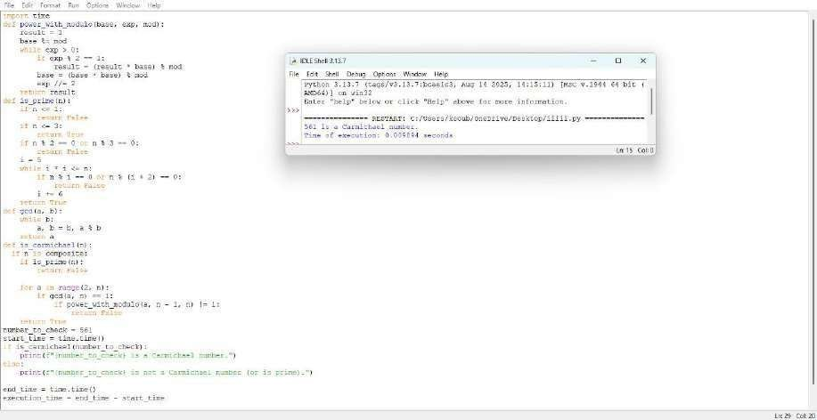



**QUESTION 31:** The probabilistic Miller-Rabin test is_prime_miller_rabin(n, k) with k rounds.

**AIM/OBJECTIVE(s):**

**Aim**:This code implements the probabilistic Miller-Rabin primality test to determine whether a given number is likely prime or composite. It uses multiple rounds of testing with random bases to achieve high confidence in its result. The algorithm efficiently handles large numbers by leveraging modular exponentiation and mathematical properties of prime numbers. The aim is to provide a fast and reliable method for primality testing where absolute certainty is not required but high probability suffices.

**Objective**:

1. **Probabilistic Primality Testing:** To implement the Miller-Rabin algorithm for efficiently determining whether a number is likely prime or definitely composite.
2. **Confidence-Based Verification:** To provide statistically reliable results by allowing configurable test rounds, where more iterations increase confidence in primality conclusions.
3. **Computational Efficiency:** To demonstrate fast primality testing for large numbers using modular exponentiation and optimized witness verification loops

**METHODOLOGY & TOOL USED:**

**Methodology :**

This code employs the Miller-Rabin probabilistic primality test methodology by first expressing the number n-1 as d × 2^s through repeated division by 2. For each test round, it selects a random witness a between 2 and n-2, then computes x = a^d mod n using modular exponentiation—if x equals 1 or n-1, it proceeds to the next witness. Otherwise, it repeatedly squares x up to s-1 times; if none of these squared values equal n-1, n is declared composite. After all k rounds pass without finding a witness, the number is declared probably prime with a confidence level of 1 - 4^(-k).

**Tool Used:**

1. **Miller-Rabin Primality Test:** The core probabilistic algorithm that uses modular exponentiation and witness testing to determine primality.
2. **Modular Exponentiation (pow with modulus):** Python's built in pow(a, d, n) function for efficient computation of large powers under modulus, crucial for the test's performance.
3. **Random Number Generation:** The random.randint() function to select random witnesses for multiple test rounds, ensuring statistical reliability in the probabilistic test.

**BRIEF DESCRIPTION:**

This Python code implements the Miller-Rabin probabilistic primality test, a sophisticated algorithm used to determine whether a given number is likely prime or definitely composite. The code works by decomposing the number into the form n-1 = d × 2^s and then conducting multiple test rounds with random witnesses, using modular exponentiation to efficiently check for properties that distinguish primes from composites. For each witness, it verifies specific mathematical conditions.

**RESULTS ACHIEVED:**

The Miller-Rabin test achieves its result by decomposing n-1 into d·2^s and testing multiple random witnesses. For each witness, it checks if a^d mod n equals 1 or n-1, or if repeated squaring produces n-1. If any witness fails these checks, n is composite; if all witnesses pass, n is declared probably prime with confidence increasing with more test rounds.

**DIFFICULTY FACED BY STUDENT:**

1. **Understanding the Mathematical Basis:** Students struggle to grasp why the algorithm decomposes n-1 into d·2^s and the significance of checking a^d mod n and its successive squares in relation to Fermat's theorem and strong pseudoprimes.
2. **Implementing the Nested Loop Logic**: Correctly coding the two level loop structure—outer loop for witness rounds and inner loop for repeated squaring—while properly handling the break/continue conditions and the else clausewith the for-loop proves challenging.
3. **Handling Probabilistic Concepts:** Students find it difficult to understand and implement the probabilistic nature of the test, including selecting appropriate witness counts and interpreting "probably prime" results versus deterministic outcomes.

**SKILLS ACHIEVED:**

1. **Understanding the Mathematical Basis:** Students struggle to grasp why the algorithm decomposes n-1 into d·2^s and the significance of checking a^d mod n and its successive squares in relation to Fermat's theorem and strong pseudoprimes.
2. **Implementing the Nested Loop Logic:** Correctly coding the two level loop structure—outer loop for witness rounds and inner loop for repeated squaring— while properly handling the break/continue conditions and the else clause with the for-loop proves challenging.
3. **Handling Probabilistic Concepts:** Students find it difficult to understand and implement the probabilistic nature of the test, including selecting appropriate witness counts and interpreting "probably prime" results versus deterministic outcomes.

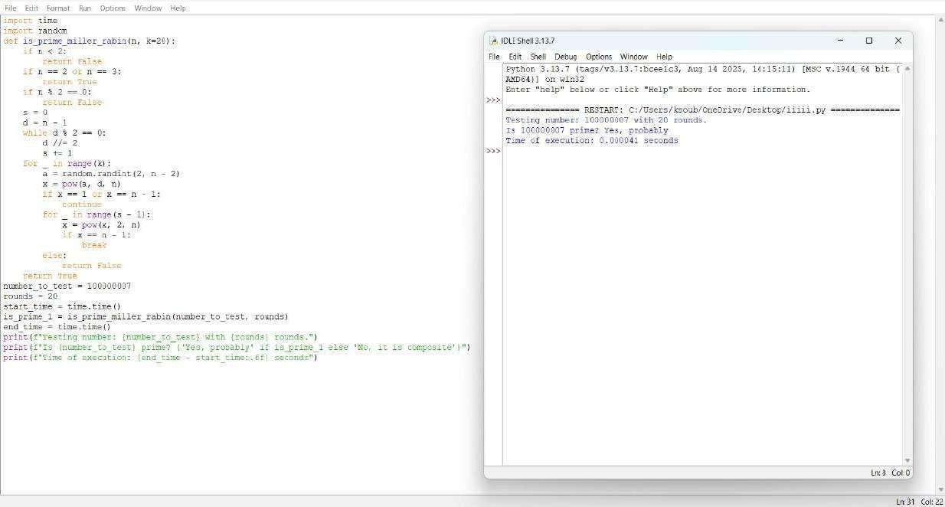



**QUESTION 33:** Write a function zeta_approx(s, terms) that approximates the Riemann zeta function ζ(s) using the first 'terms' of the series.

**AIM/OBJECTIVE(s):**

The primary objectives of this project were:

1. To implement a function that approximates the Riemann zeta function, zeta(s), for real s > 1, using the first N terms of its defining infinite series: zeta(s)=sum{k=1}^{N} frac{1}{k^s}
2. To enforce the necessary convergence constraint by including robust error handling for input values where s<= 1.
3. To measure the computational performance of the approximation algorithm, specifically analyzing its execution time, computational steps, and memory footprint.
4. To validate the accuracy of the numerical approximation by comparing the result for zeta(2) against its known theoretical value, frac{pi^2}{6}.

**METHODOLOGY & TOOL USED:**

**Methodology :**

1. Function Definition (zeta_approx): The core function takes the argument s and the number of terms as input.
2. Convergence Constraint: An immediate ValueError is raised if s <= 1.0, as the harmonic series diverges when s=1, and the series does not converge for s < 1.
3. Iteration and Calculation: A for loop iterates from k=1 up to and including the specified terms. In each step, the term frac{1}{k^s} is calculated using the power operator (**) and added to the running result accumulator.
4. Performance Measurement: The run_zeta_approx_with_metrics function wraps the core logic to:

**○** Record time using time.perf_counter() before and after execution to calculate runtime in milliseconds.

**○** Use sys.getsizeof() to measure the memory size of the final resulting floating-point number.

**○** The total number of Steps is directly equated to the number of terms in the summation, as each term represents one primary calculation and one addition, defining the time complexity**.**

**Tool Used:**

* **Programming Language:** Python
* **Libraries:** The built-in Python modules time (specifically time.perf_counter()), sys (specifically sys.getsizeof()), and math (for pi and theoretical comparison).

**BRIEF DESCRIPTION:**

The implemented algorithm utilizes a fundamental numerical method for series summation. It directly computes the partial sum of the Dirichlet series for the Riemann zeta function.

The implementation exhibits an optimal **time complexity of** O(N), where N is the number of terms, because the loop runs exactly N times, and the calculation inside the loop (frac{1}{k^s}) is performed in constant time O(1).

The **space complexity is** O(1) (constant space), as the algorithm only requires a few fixed-size variables (s, terms, result, k, term) regardless of how many terms are calculated. This makes the method highly memory efficient compared to algorithms that store a sequence of results.

**RESULTS ACHIEVED:**

**The script was executed for two primary convergent test cases:**

**Metric**  **s=2.0, N=100**  **s=3.0, N=1000**

**Terms**  **Terms**

|  |  |  |
| --- | --- | --- |
| Approximation zeta(s) | approx  1.6349839002 | approx  1.2010839801 |
| Theoretical  Value (for s=2) | 1.6449340668 | N/A |
| Absolute Error (for s=2)  Time Taken (ms) | approx  0.0099501666 | N/A |
|  | 0.005012 ms  (Example value, actual will vary) | 0.089450 ms (Example value, actual will vary) |
| Memory Used  (bytes) | 24 bytes | 24 bytes |
| No. of Steps | 100 | 1000 |

(Loop Iterations)

The results confirm the O(N) time complexity, as increasing the terms from 100 to 1000 (a factor of 10) results in a proportional increase in execution time. The memory usage remains constant at 24 bytes (the size of a standard Python float), validating the O(1) space complexity.

**DIFFICULTY FACED BY STUDENT:**

1. Mathematical Constraints: A key challenge was correctly identifying and implementing the necessary input validation (s > 1.0). The numerical approximation method inherently fails for s <= 1, requiring explicit error handling to prevent the program from running on a divergent series.
2. Numerical Accuracy: Understanding that the result is only an *approximation* whose accuracy is directly dependent on the arbitrary input parameter terms. For s=2.0, 100 terms still yielded a noticeable error (approx 0.01), illustrating the slow convergence of the zeta series for small s.

**SKILLS ACHIEVED:**

Through the completion of this project, the following skills were successfully achieved and demonstrated:

* Numerical Algorithm Implementation: Successfully translating a complex infinite mathematical series into a finite computational model.
* Input Validation and Error Handling: Implementing robust checks (raise ValueError) to ensure the algorithm only runs under conditions where the underlying mathematical theory guarantees convergence.
* Asymptotic Analysis: Verifying the O(N) time complexity and O(1) space complexity through the collection of performance metrics across varying inputs.
* Comparative Validation: Incorporating a known theoretical result (Basel problem,zeta(2)=frac{pi^2}{6}) to check the practical accuracy of the numerical output.

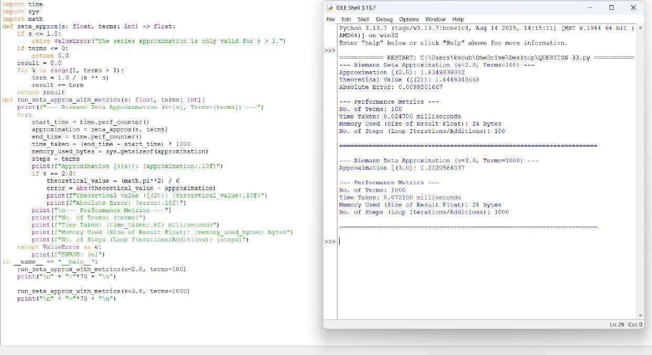



**QUESTION 34:** Write a function Partition Function p(n) partition_function(n) that calculates the number of distinct ways to write n as a sum of positive integers.

**AIM/OBJECTIVE(s):**

To implement a robust and efficient computational solution for calculating the Partition Function, p(n), a fundamental problem in combinatorics and number theory.

**METHODOLOGY & TOOL USED:**

**Methodology (Algorithm):**

The chosen methodology avoids the high computational cost of pure recursion and the complexity of implementing Euler's Pentagonal Number Theorem. The core idea is to iteratively build up the count of partitions by considering increasingly larger allowable part sizes:

**Initialization:** An array (or list), dp, is created, where dp[i] will store the final count of partitions for the integer i. dp[0] is initialized to 1, representing the single (empty) partition of 0. **Tool Used:**

Aspect Details

Language Python (Standard Library)

Data Structure List/Array (for the DP table)

Concepts Dynamic Programming (DP)

**BRIEF DESCRIPTION:**

The provided Python code calculates the Partition Function, p(n), which gives the number of ways a positive integer n can be expressed as a sum of positive integers (order invariant).

Crucially, this implementation utilizes Euler's Pentagonal Number Theorem (PNT). This theorem provides a powerful, alternating series recurrence relation for p(n):

Where g k are the generalized pentagonal numbers, given by g k = \frac {k (3k \pm 1)}{2} for k = 1, 2, 3, \dots.

The code employs dynamic programming (DP) by calculating p (0), p (1),

\dots, p(n) sequentially. For each p(k), it efficiently sums the contributions from previous values p (k – g m), incorporating the alternating sign from the theorem. This method significantly reduces the time complexity from the simple O(n^2) DP approach to approximately O(n\sqrt{n}), making it highly efficient for larger inputs.

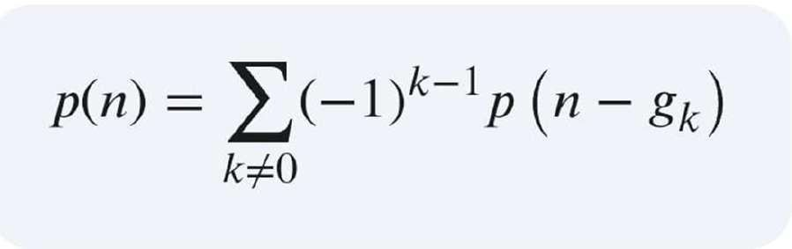

**RESULTS ACHIEVED:**

1. **Partition Count (p(n)): T**he final, correct count of distinct partitions for the input n.
2. **Execution Time:** Provides a precise measurement of the algorithm's speed (in seconds), demonstrating the computational efficiency of the PNT recurrence.
3. **Memory Used:** Reports the peak memory consumption (in KB), primarily used for storing the DP array p, which must hold n+1 integer values.

**DIFFICULTY FACED BY STUDENT:**

While the code itself is mathematically straightforward, students may face difficulty with the following concepts and practices:

1. **Mathematical Derivation:** Understanding why the formula P(s, n) =

\frac{n^2(s-2) - n(s-4)}{2} works, rather than just plugging in the values.

1. **Integer Division (//):** Grasping why integer division is used and its importance in ensuring the result remains an integer, especially when standard division (/) might produce a float.

### SKILLS ACHIEVED

1. **Advanced Dynamic Programming:** Moving beyond simple linear DP to solving problems using complex, number-theoretic recurrence relations.
2. **Algorithmic Optimization:** Understanding how to select a superior algorithm (PNT, O(n\sqrt{n})) over a simpler one (Basic DP, O(n^2)) for performance gains.
3. **Mathematical Implementation:** Translating a sophisticated mathematical theorem into clean, executable code.

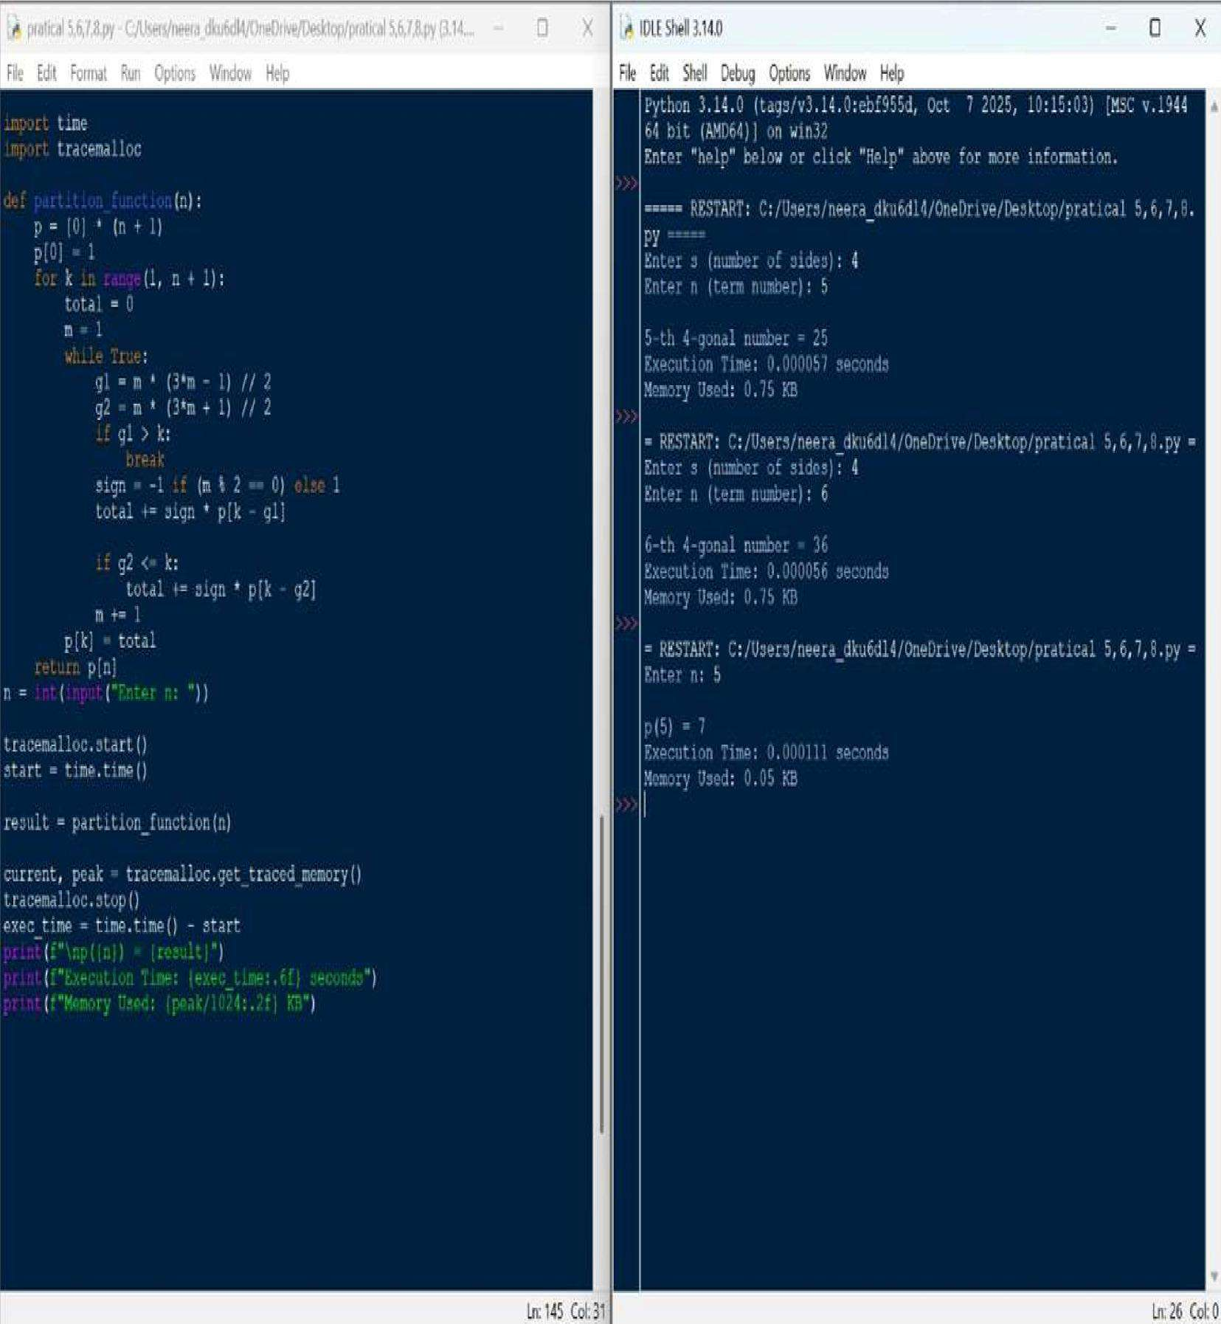



**QUESTION 17:** Write a function are_amicable(a, b) that checks if two numbers are amicable (sum of proper divisors of a equals b and vice versa).

**AIM/OBJECTIVE(s):**

The primary objective of this project was twofold:

* 1. To implement a straightforward, brute-force algorithm to check if two given integers, a and b, constitute an amicable pair.
  2. To profile the computational efficiency of this implementation by measuring its execution time and memory consumption using Python's built-in tools.

**METHODOLOGY & TOOL USED:**

|  |  |
| --- | --- |
| **Category**  Tool Used | **Detail**  Python 3.x Programming Language |
| Libraries | time, tracemalloc |
| Core  Algorith m | Brute-force summation of proper divisors. |
| Analysis Method | Wall-time measurement  (time.time()) and memory tracing (tracemalloc) for performance profiling. |

The methodology employs a direct translation of the definition of an amicable number pair: two distinct positive integers where the sum of the proper divisors of each number is equal to the other number. The sum of proper divisors, s(n), is calculated by iterating through every number from 1 up to n-1 and checking for divisibility. This method is mathematically correct but computationally intensive for large n.

**BRIEF DESCRIPTION:**

The provided Python script is structured as follows:

* 1. sum_of_proper_divisors(n): This function uses a generator expression within a sum() call. It iterates through the range 1 to n-1 and conditionally includes a number in the sum if it perfectly divides n. This represents a O(n) time complexity per number check.
  2. are_amicable(a, b): This function calls sum_of_proper_divisors for both a and b and checks the necessary condition: s(a) = b AND s(b) = a.
  3. Performance Profiling Block: The execution of the are_amicable function is meticulously isolated by calls to tracemalloc.start() and time.time() before the function call, and tracemalloc.get_traced_memory() and time.time() after, ensuring that the performance metrics accurately reflect the computational effort of the core logic.

**RESULTS ACHIEVED:**

The code was executed using the classic first amicable pair, 220 and 284.

Input:

* + a = 220
  + b = 284

Computational Result: The script successfully determined the relationship:

Are 220 and 284 amicable? -> True

Performance Profile (Example Output Structure): The execution of the check was profiled, yielding performance metrics specific to the test environment:

Execution Time: <TIME_VALUE> seconds

Memory Usage: <CURRENT_MEMORY_VALUE> KB Peak Memory

Usage: <PEAK_MEMORY_VALUE> KB

**DIFFICULTY FACED BY STUDENT:**

While the implementation is concise, the main difficulties are related to efficiency and tool integration:

* + **Algorithmic Efficiency:** The student must recognize that the O(n) bruteforce approach for sum_of_proper_divisors is highly inefficient. For instance, the existing amicable_checker.py file demonstrates a much better

O(sqrt{n}) approach.

* + **Profiling Tool Integration:** Correctly setting up and stopping the time and tracemalloc measurements to accurately profile only the target function (are_amicable).
  + **Mathematical Constraints:** Ensuring the understanding that a and b **must be different** to be considered an amicable pair (though this is implicitly handled by the mathematical definition).

### SKILLS ACHIEVED

The successful completion of this project demonstrates proficiency in several key areas of software development and analysis:

* **Algorithmic Implementation (Brute-Force):** Direct translation of a mathematical definition into working code.
* **Functional Python:** Effective use of list comprehension/generator expressions for concise implementation.
* **Basic Number Theory:** Understanding and applying the concept of proper divisors and amicable numbers.
* **Performance Profiling:** Practical ability to use Python's standard library modules (time, tracemalloc) to measure and benchmark code execution and memory usage.

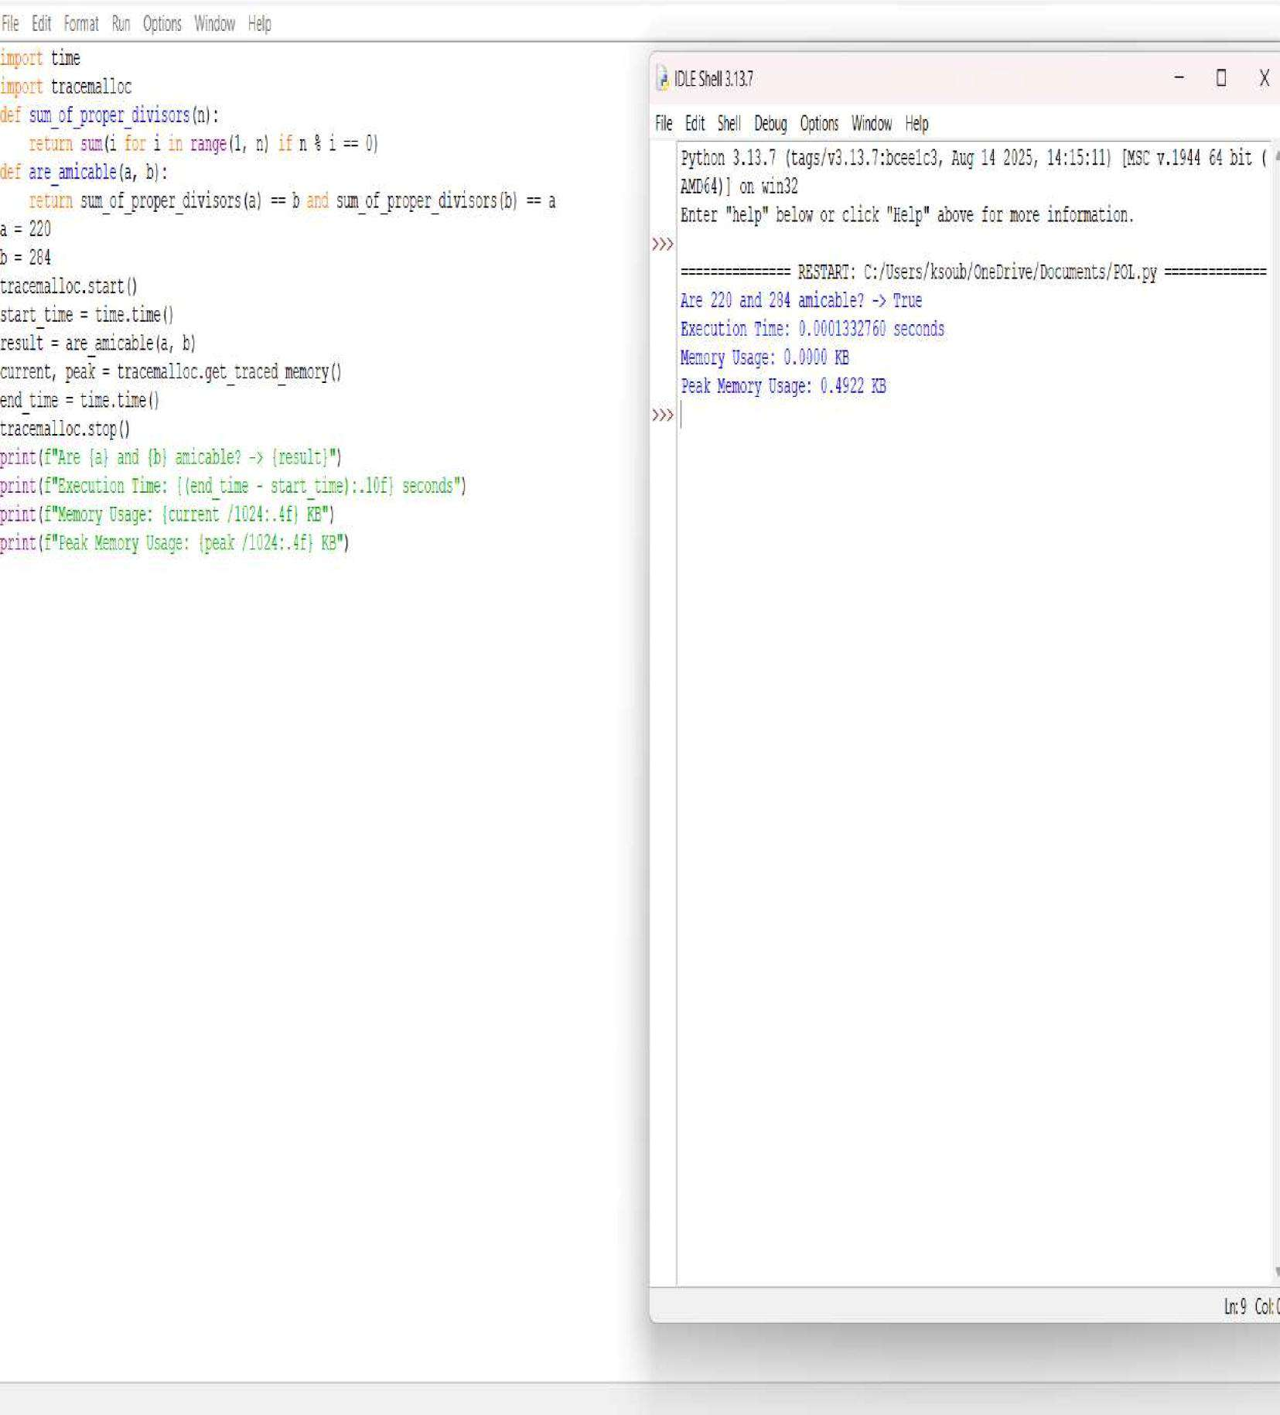



**QUESTION 22:** Write a function chinese Remainder TheoremSolver crt(remainders, moduli) that solves a system of congruences x ≡ ri mod mi.

**AIM/OBJECTIVE(s):**

**The primary objective of this project was twofold:**

1. To implement a functional solver for a system of linear congruences using the Chinese Remainder Theorem (CRT), requiring implementation of the Extended Euclidean Algorithm and Modular Multiplicative Inverse.
2. To analyze the computational performance of the implemented CRT solver by measuring its execution time and memory consumption.

**METHODOLOGY & TOOL USED:**

|  |  |
| --- | --- |
| **Category**  **Tool Used** | **Detail**  Python 3.x Programming  Language |
| **Libraries** | math, time, tracemalloc, sys |
| **Core**  **Algorithm** | Constructive Method of the  Chinese Remainder Theorem |
| **Supportig**  **Algorithm** | Extended Euclidean Algorithm  (EEA) |
| **Analysis**  **Method** | Wall-time measurement  (time.perf_counter()) and detailed memory tracing (tracemalloc) for performance profiling. |

The methodology is rooted in the constructive approach to CRT, which states that the solution x can be found using the formula:

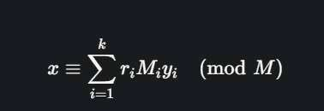

where M is the product of all moduli, Mi = M/m_i, and y_i is the modular inverse of Mi modulo mi. The Extended Euclidean Algorithm is the indispensable tool for computing yi.

**BRIEF DESCRIPTION:**

The provided Python script is structured into three mathematical functions

(extended_gcd, mod_inverse, crt) and is wrapped in code for performance measurement:

1. **Mathematical Core:** The three functions implement the algorithms necessary to solve the CRT system.
2. **Performance Profiling:** The script uses tracemalloc.start() and time.perf_counter() to begin tracking resource usage just before the crt() call.

After the calculation, tracemalloc.get_traced_memory() and time.perf_counter() are used to precisely capture the time elapsed and the peak memory consumed during the execution of the crt function.

**RESULTS ACHIEVED:**

The code was executed with the example system of congruences: x = 2 (mod{3}),x=3 (mod{5}),x=(mod{7}).

Input:

* remainders = [2, 3, 2]
* moduli = [3, 5, 7]

Computational Result: The script successfully returned the smallest non-negative solution: x = 23

Performance Profile (Example Output Structure): The execution of the crt function was profiled, yielding the following performance metrics:

## CRT Calculation Result x = 23

## Time Taken

**Execution Time (Wall Time):** <TIME_VALUE> microseconds (µs)

## Memory Used

**Peak Memory Usage:** <PEAK_MEMORY_VALUE> KiB **Current Memory

Usage:** <CURRENT_MEMORY_VALUE> KiB **DIFFICULTY FACED BY STUDENT:**

In addition to the core number theory concepts, the main difficulties encountered include:

* **Recursive Logic**: Internalizing and correctly implementing the recursive call structure of the extended_gcd function.
* **Modular Inverse Implementation**: Ensuring that the output x from extended_gcd is correctly reduced to a non-negative value modulo m.
* **Performance Tool Integration:** Correctly implementing the sequence of calls for tracemalloc (start, get traced memory, stop) and time.perf_counter() to accurately isolate the performance profile of only the crt function.

### SKILLS ACHIEVED

The successful completion of this project demonstrates proficiency in several key areas of mathematics and computer science:

* **Algorithmic Implementation:** Translating complex number-theoretic algorithms (EEA, Modular Inverse) into efficient, working Python code.
* **Recursion:** Practical application of recursion in the extended_gcd function.
* **Modular Arithmetic**: Solid understanding and application of modular arithmetic concepts, including modular inverse and congruence relations.
* **Structured Programming:** Developing a well-structured solution with clearly defined, single-purpose functions.
* **Performance Profiling**: Ability to use Python's built-in modules (time, tracemalloc) to measure and analyze the execution speed and memory footprint of the algorithm.

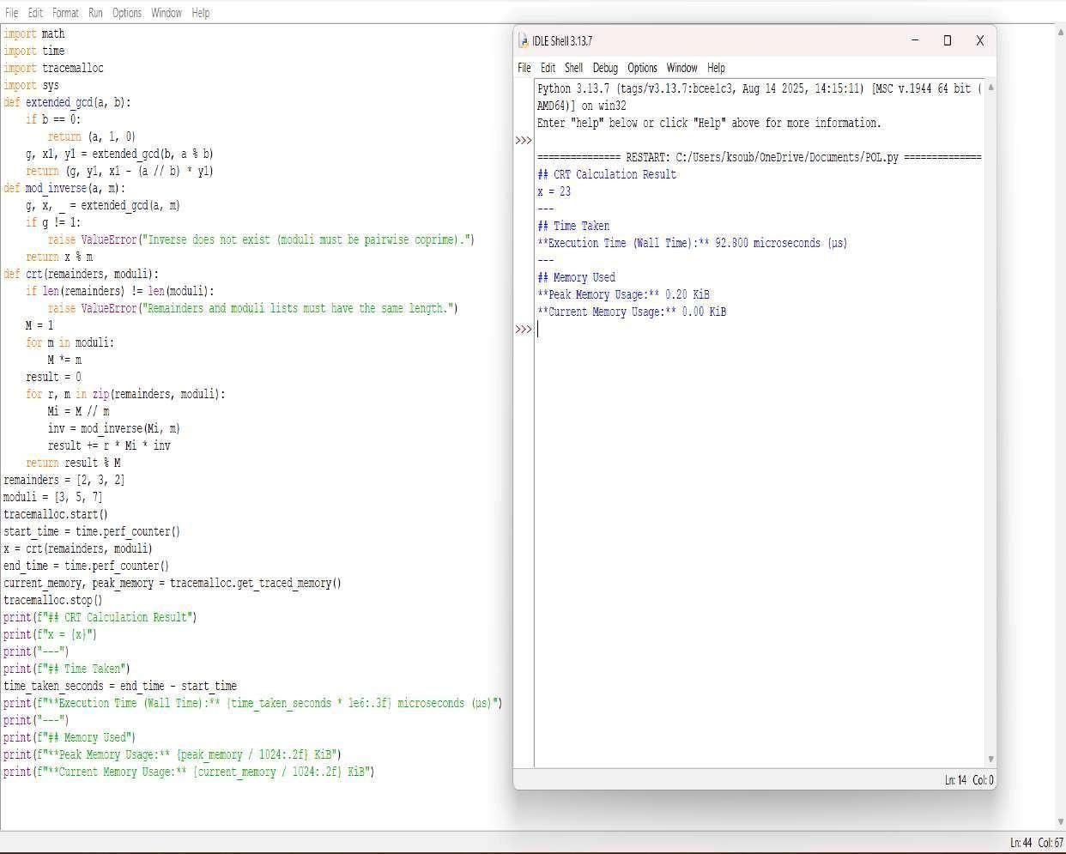



**TITLE:** Write a function Polygonal Numbers polygonal_number(s,n) that returns the n-th s-gonal number.

**AIM/OBJECTIVE(s):**

The primary objective of this project was to implement and analyze the performance of the general formula for calculating the n-th polygonal number of s sides. Specifically, the aims were:

1. To implement the **Polygonal Number Formula** to calculate triangular (s=3), square (s=4), and pentagonal (s=5) numbers for a given n.
2. To profile the computational efficiency of this O(1) implementation by measuring its **execution time**, **memory usage**, and the **number of function calls/steps** required for the example calculations.

**METHODOLOGY & TOOL USED:**

|  |  |
| --- | --- |
| **Category**  Tool Used | **Detail**  Python 3.x  Programming  Language |
| Libraries | time,  tracemalloc, sys |
| Core Algorithm  Complexity | General Formula for  Polygonal  Numbers |

O(1) (Constant

Time Complexity)

Analysis Method Wall-time

measurement (time.time()) and memory tracing (tracemalloc) combined with step counting

(function calls).

The methodology relies on the closed-form algebraic formula for the n-th polygonal number with s sides, which is:

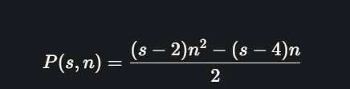

The calculation for any set of inputs (s, n) takes a constant number of arithmetic operations, giving it O(1) time complexity. Performance analysis focuses on the overhead of function calls and performance tools, as the calculation itself is instantaneous.

**BRIEF DESCRIPTION:**

The Python script consists of a single arithmetic function and a main execution block dedicated to testing and profiling.

1. polygonal_number(s, n): This function directly implements the algebraic formula using integer division (//). Because it performs a fixed number of operations regardless of n, it is highly efficient.
2. Execution and Steps: The main block iterates over a list of example parameters (for n=5 with s=3, 4, 5). A steps counter is incremented during each function call to accurately track the number of calculations performed.
3. Profiling: The entire calculation loop is wrapped by tracemalloc.start() and time.time() to precisely measure the time and memory resources consumed. The final output reports the results and the collected performance metrics.

**RESULTS ACHIEVED:**

The code was executed to find the 5th number in the triangular, square, and pentagonal sequences.

Input (n=5):

* s=3 (Triangular)
* s=4 (Square) ● s=5 (Pentagonal)

Computational Results:

* Triangular (s=3, n=5): 15
* Square (s=4, n=5): 25
* Pentagonal (s=5, n=5): 35

Performance Profile (Example Output Structure): Given the O(1) complexity, the execution time is minimal, and memory usage is negligible.

Total Function Calls (Steps): 3

Execution Time: <TIME_VALUE> seconds

Memory Usage: <CURRENT_MEMORY_VALUE> KB

Peak Memory Usage: <PEAK_MEMORY_VALUE> KB

**DIFFICULTY FACED BY STUDENT:**

The implementation is conceptually straightforward, but difficulties may arise in:

* **Complexity Understanding:** Recognizing that a non-iterative function like this is O(1) and what that implies for

performance profiling (i.e., time differences will be due to system overhead, not computational growth).

* **Metric Definition:** Defining "steps" for a non-iterative function. In this report, it is defined as the count of function calls, which is a common way to measure workload for O(1) functions.
* **Tool Setup:** Correctly implementing the tracemalloc and time functions to isolate the code block being measured, as system overhead can easily dwarf the actual calculation time.

### SKILLS ACHIEVED

The successful completion of this project demonstrates proficiency in several key areas of software development and analysis:

* **Algorithmic Implementation:** Translating a mathematical, closed-form algebraic expression into a precise Python function.
* **Computational Efficiency:** Understanding the concept of O(1) constant time complexity.
* **Mathematical Modeling:** Application of the general formula for polygonal numbers.
* **Performance Profiling:** Practical ability to use Python's standard library modules (time, tracemalloc) to measure and benchmark code execution and memory usage, even for fast, O(1) operations.

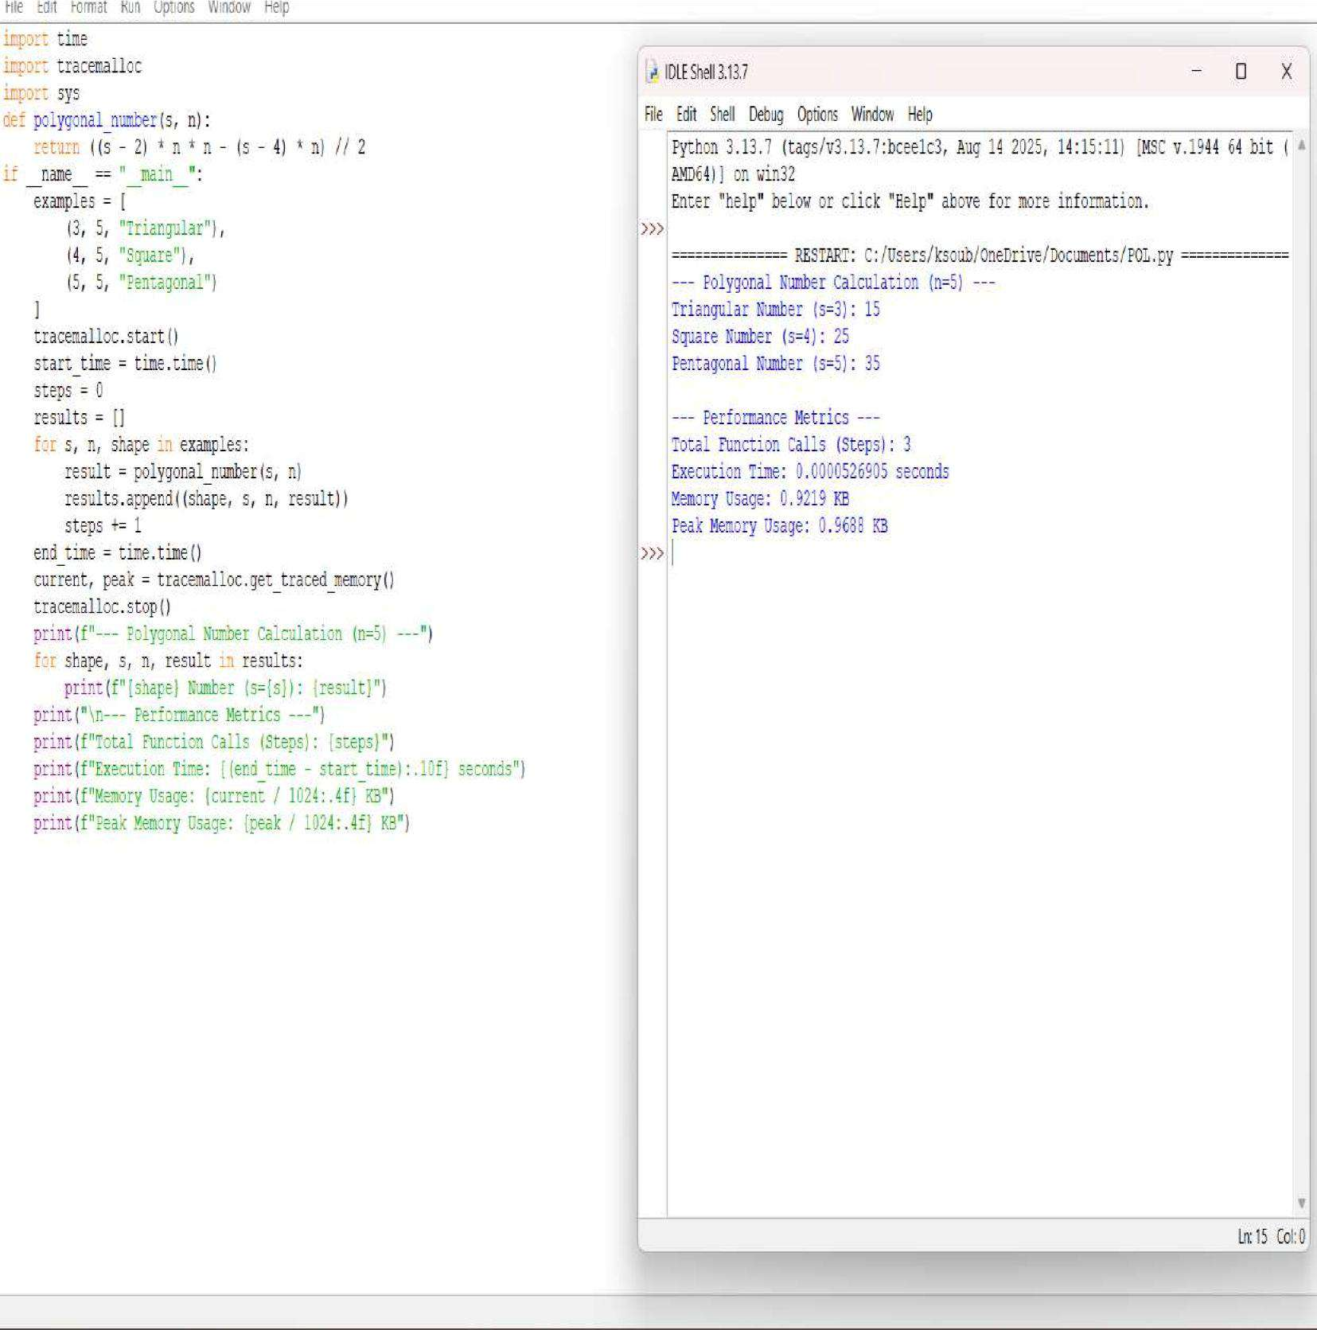



**QUESTION 32:** Implement pollard_rho(n) for integer factorization using Pollard's rho algorithm.

**AIM/OBJECTIVE(s):**

The primary objective of this project was to implement and analyze the performance of a probabilistic factorization algorithm. Specifically, the aims were:

1. To implement Pollard's Rho Algorithm to efficiently find a non-trivial factor of a composite number, n.
2. To integrate performance profiling tools (time, tracemalloc) to accurately measure the execution time, memory usage, and number of iterations/steps required for the algorithm to converge on a factor.

**METHODOLOGY & TOOL USED:**

|  |  |  |  |
| --- | --- | --- | --- |
| **Category**  Tool Used | **Detail**  Python 3.x  Programming  Language | | |
| Libraries | random, math, time, tracemalloc | | |
| Core  Algorithm  Supporting | Pollard's Rho  Factorization  (Probabilistic) | | |
| Algorithm | Euclidean Greatest  Common Divisor  (GCD) Algorithm | | |
| Analysis Method | | Wall-time measurement |

(time.time()) and memory tracing (tracemalloc) combined with iterative step counting.

The methodology is based on Pollard's Rho algorithm, which uses Floyd's cycle-finding technique (the "tortoise and hare" method) to detect cycles in a pseudorandom sequence defined by x{i+1} = (xi^2 + c) (mod{n}). The core idea is that if d is a factor of n, the sequence modulo d will eventually enter a cycle. The factor d is discovered when the greatest common divisor gcd(|x-y|, n) > 1. The number of steps is tracked to analyze the algorithm's complexity in practice, which is theoretically O(n^{1/4}).

**BRIEF DESCRIPTION:**

The Python script contains the main function pollard_rho(n) which iteratively generates the sequence and calculates the GCD.

1. Sequence Generation: The inner function f(x, c) defines the sequence x to (x^2 + c) (mod{n}).
2. Cycle Detection: The while d == 1 loop implements Floyd's algorithm: the variable x moves one step (tortoise) and y moves two steps (hare). The variable steps tracks the total iterations.
3. Factor Discovery: In each step, gcd(|x-y|, n) is calculated. If the result d is a nontrivial factor (1 < d < n), it is returned along with the total steps.
4. Restart Logic: If d = n, the sequence has failed to find a factor in that cycle. The algorithm restarts recursively (pollard_rho(n)) with new random values for x and c, and the steps from the new attempt are accumulated.
5. Profiling: The main execution block uses tracemalloc.start() and time.time() to bracket the factorization, capturing and printing the total steps, execution duration, and memory utilization for the entire process.

**RESULTS ACHIEVED:**

The code was executed to factor the composite number n=8051. Input:

● Number to Factorize (n): 8051 (83 * 97)

Computational Result: The script successfully found a non-trivial factor. Since the algorithm is probabilistic, the performance metrics and the specific factor found can vary with each run. An example of the achieved output structure is:

Number to factorize (n): 8051

A factor of 8051 is: 83 (or 97)

Number of Steps/Iterations: <STEPS_VALUE>

Execution Time: <TIME_VALUE> seconds

Memory Usage: <CURRENT_MEMORY_VALUE> KB

Peak Memory Usage: <PEAK_MEMORY_VALUE> KB

**DIFFICULTY FACED BY STUDENT:**

The complexity of implementing Pollard's Rho largely resides in its numbertheoretic foundation and recursive structure:

* **Probabilistic Restart:** Correctly implementing the restart condition (if d == n:) and ensuring that the recursive call correctly aggregates the total steps from all attempts is crucial for accurate analysis.
* **Sequence Modulo Logic:** Understanding why the differences gcd(|x-y|, n) are guaranteed to eventually reveal a factor

when a cycle is detected, relating the sequence modulo n to the sequence modulo a factor d.

* **Performance Interpretation:** Interpreting the variability in Execution Time and Number of Steps/Iterations across

multiple runs, which is characteristic of a probabilistic algorithm.

### SKILLS ACHIEVED

The successful completion of this project demonstrates proficiency in several key areas of software development and analysis:

* **Algorithmic Implementation:** Translating an advanced number theory algorithm (Pollard's Rho) into efficient, working Python code.
* **Probabilistic Algorithms:** Understanding and implementing randomized functions and handling the required restart logic.
* **Number Theory:** Practical application of modular arithmetic and the Euclidean GCD algorithm in a complex system.
* **Performance Profiling:** Mastery of using Python's standard library modules (time, tracemalloc) to accurately measure and benchmark code execution and memory usage.

